How to add password to your Wi-Fi connection

Why you need a password for your Wi-Fi connection?
The factory setting does not set any password to the Wi-Fi connection . For protecting your data from unauthorized access, We recommend you need to set a password to your Wi-Fi connection.

PC/Laptop
1. Switch your Wi-Fi connection to BellnetXXXXXX (By default your Q Station's Wi-Fi connection is something like this)
2. Access 172.16.0.1 with your Internet browser.
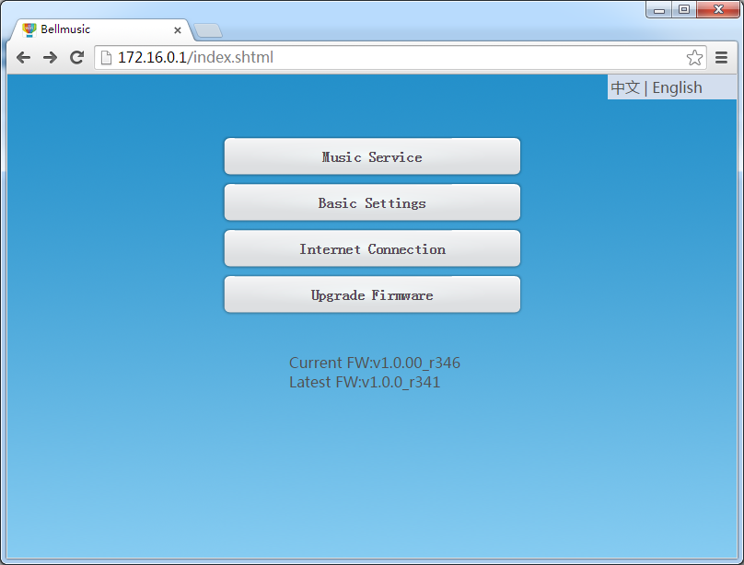
3. Click 'Basic Settings' button and select Wi-Fi encryption method from the security drop-down menu.

WEP is not a strong Wi-Fi encryption method and hacker can get your password within few minutes. So we recommend you'd better select WPA/WPA2 as your Wi-Fi encryption method.
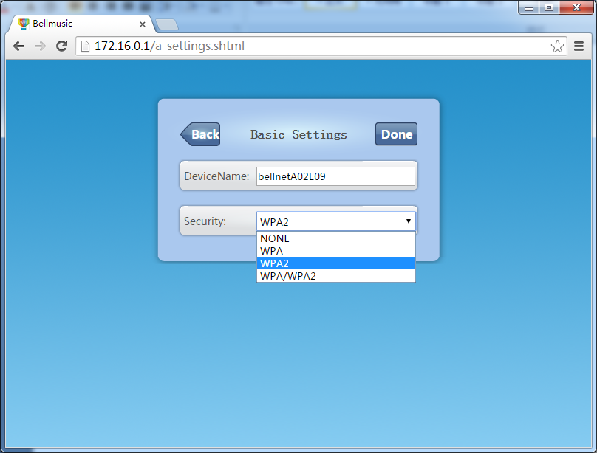
4. Enter the password and re-type the password, then click Done button to take this change effect within 25 seconds.
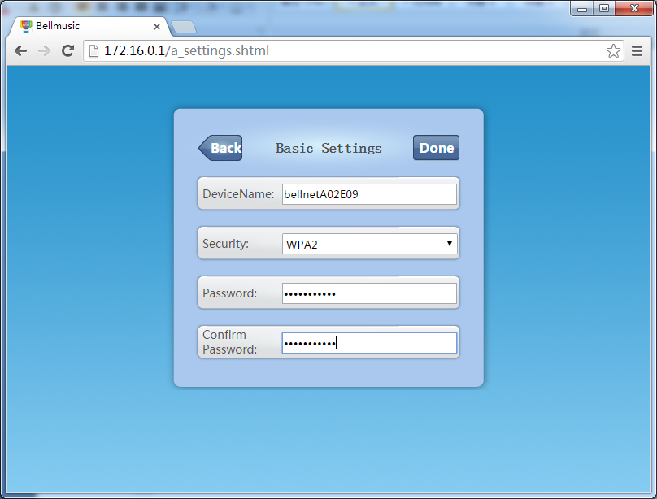
IOS
1. Search 'bellq' from App Store and install it on your iPhone
2. Run BellQ and click setting icon
3. Click 'Basic Settings' button and select Wi-Fi encryption method from the security drop-down menu.
WEP is not a strong Wi-Fi encryption method and hacker can get your password within few minutes. So we recommend you'd better select WPA/WPA2 as your Wi-Fi encryption method.
4. Enter the password and re-type the password, then click Done button to take this change effect within 25 seconds.

Android
1. Search 'qlight' or 'bellq' from Google Play and install it on your Android smart phone (BellQ is our full features application)
2. Run Qlight or BellQ and click setting icon
3. Click 'Basic Settings' button and select Wi-Fi encryption method from the security drop-down menu.
WEP is not a strong Wi-Fi encryption method and hacker can get your password within few minutes. So we recommend you'd better select WPA/WPA2 as your Wi-Fi encryption method.
4. Enter the password and re-type the password, then click Done button to take this change effect within 25 seconds.

